SEPTEMBER MEETING NOTICE
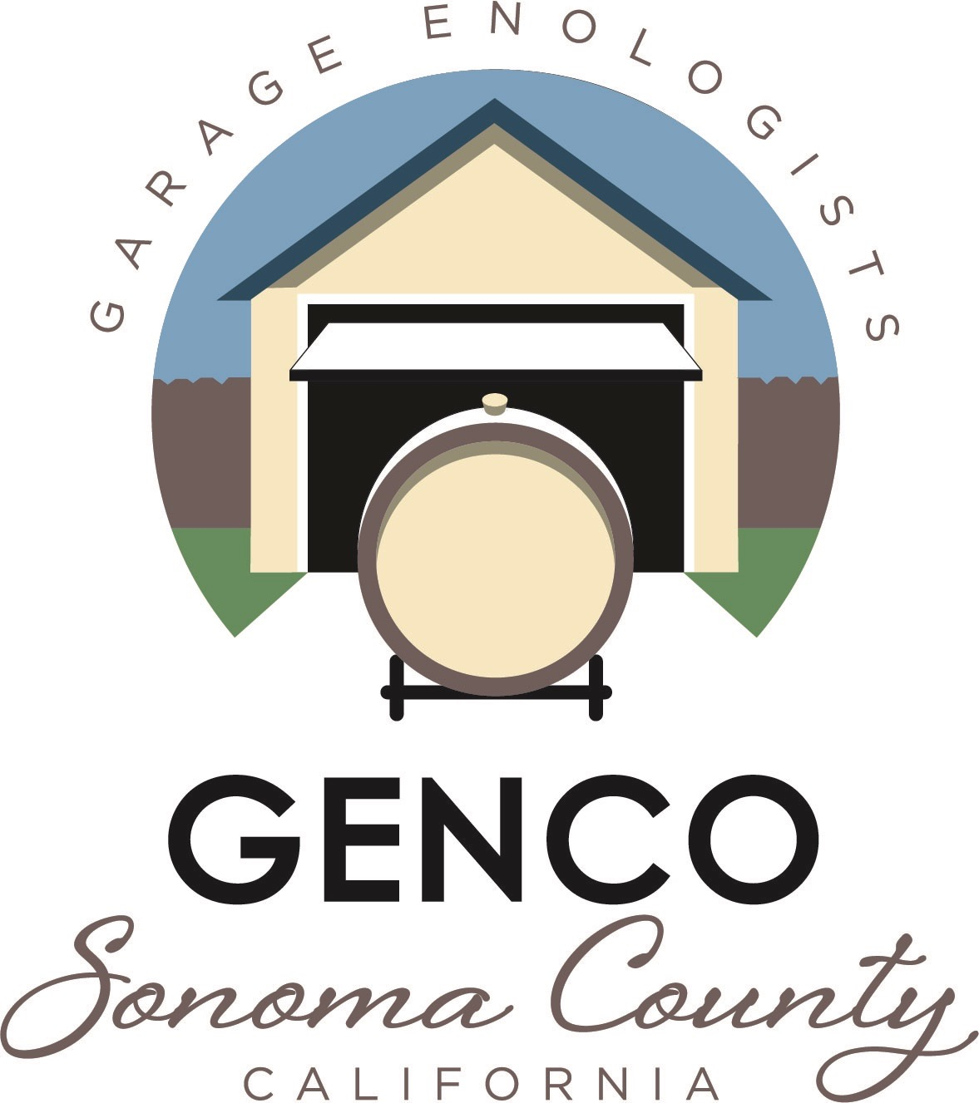

Date: Wednesday-September 25, 2019
Place: Good Shepherd Lutheran Church

Time: 7:00 pm
Wine Glasses: 1
Topic: Harvest
Speaker: Bruce Hagen
Education Coordinator

Educational program for September:
We are in the thick of harvest, so we’ll talk about how harvest is shaping up, quality of grapes, acid level, fermentation problems, etc.

I also want to talk about starting a GENCO co-op to buy selected fermentation products, new bottles, etc. We could also strike an agreement with Gabe at the Beverage people to sell some of the more expensive products in small quantities. The Harvest Fair results are out, and as you would expect, GENCO members did quite well. so let’s taste some of those gold medal wines. We’ll provide the appetizers, you bring a wine...

Bruce Hagen, GENCO Education Coordinator
827-3399

www.gencowinemakers.com

